Computer programming

Final Project

Report

I.E.S. San Vicente
San Vicente del Raspeig (Alicante)
2017/2018

Teachers:
José Ignacio Cabanes / Ignacio Iborra

Student:
Javier Cases Sempere

1. Introduction
Project name
ggLoL

Made by
Javier Cases Sempere

Short description of the project
Informative application about the video game League of Legends. With options to view profiles of players, spectate games, general information of the game, participation in tournaments, creator / search engine of teams and offline mode. Created using Windows Forms, the MaterialSkin framework (in the visual section), the Newtonsoft Json.NET framework, and the official League of Legends API.

2. Functionality of the project
Once the program has started, we have the options to register or login.
Once we have completed the login or registration, we will have several options, including:

- Basic information of the game (champions, skins, masters, profile icons, maps, spells or objects).
- Player's information and status (best champion, current starting status and possibility to watch -only if it is in game-, level, leagues in ranked, possibility of downloading CV about in-game experience (in PDF) and profile in application (in the previous registration).
- Search of equipment or search of players to play in game, together with private and public chat to communicate with other players.
- Game news (news, patch notes, free champions, offers).
- Overlay in game (to be able to see the information of your enemies before starting the game).

If the user clicks "Game Information", he will be shown static data of the game. Everything organized and intuitive so that the user has an easy handling of the application.

If the user clicks "Player Information", he / she will be able to see his / her personal profile, his / her state in game - if he / she is playing one at that moment -, his level, his leagues in competitive and his username in the ggLoL application. If it is your own profile, you will have the option of downloading your profile information in PDF.

If the user clicks "Search Player / Team", he will have the option to create a team and search for players or look for a team in which to play.

If the user clicks on "News", he will be able to inform himself of all the novelties of the game. This page will be the initial one after logging in.

If the user configures "Overlay in Game", the loading screen will show all the information of the game, both his teammates and his enemies, superimposed.

The application will have the option to download all data (images and videos) locally, so you do not have to constantly make requests. The icons will be downloaded the first time there will be an application. In addition, the user can exchange between a clear and dark subject.

3. Screen prototype
The login screen will be displayed so that:

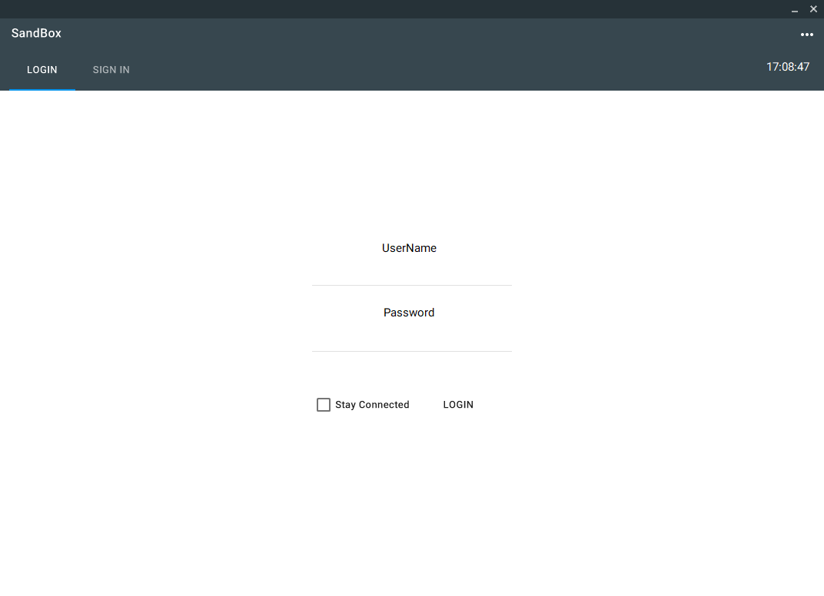

The screen once the session is started will be displayed in the following way:

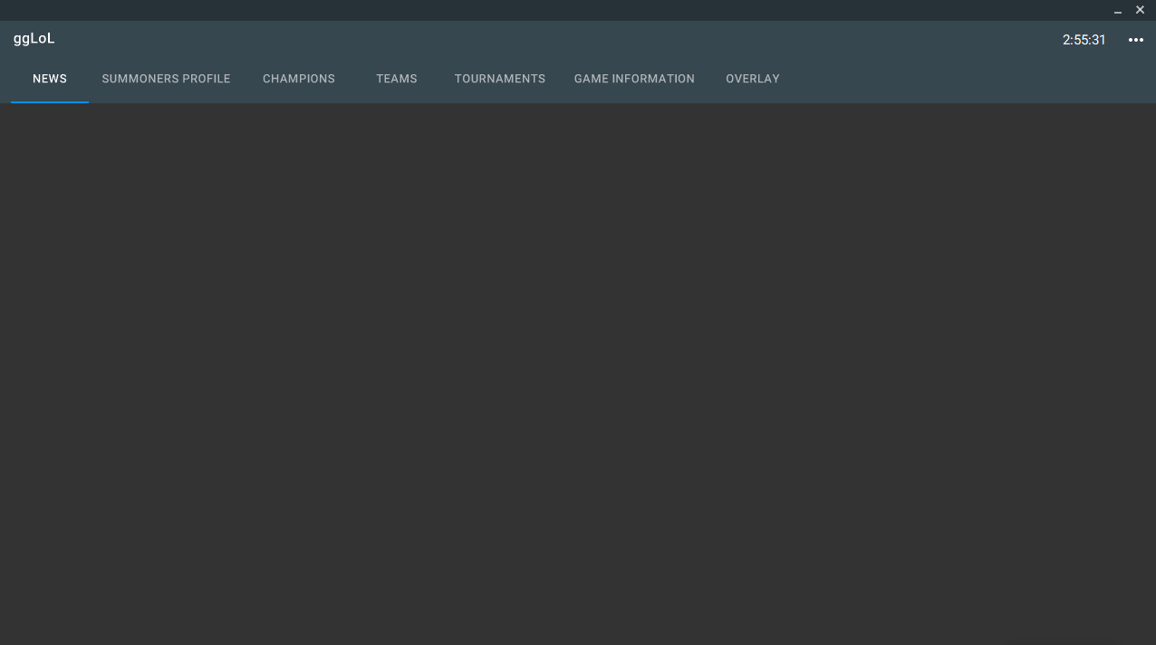

4.Analysis

4a. Requisites
Requisite | Date achieved
The application must have the option to change themes, main colours and see correctly the different sections.
The application must show the information of all the champions, with or without connection.
The application must show the player profile information, with or without connection. You must also show the profile information of the players you are looking for, only with a connection.
The application must show the static information of the game, with or without connection.
The application must allow the download of your profile in PDF, with or without connection.
The application must correctly show all the images obtained from the internet, or through a local copy.
The application must correctly show the news of the game with or without connection.
The application must have a correct implementation with the video game League of Legends.
The application must have a proper database of its own for the registration and access of users.
The application must have a completely operational offline mode.

4b. Basic pseudocode

4c. Classes diagram
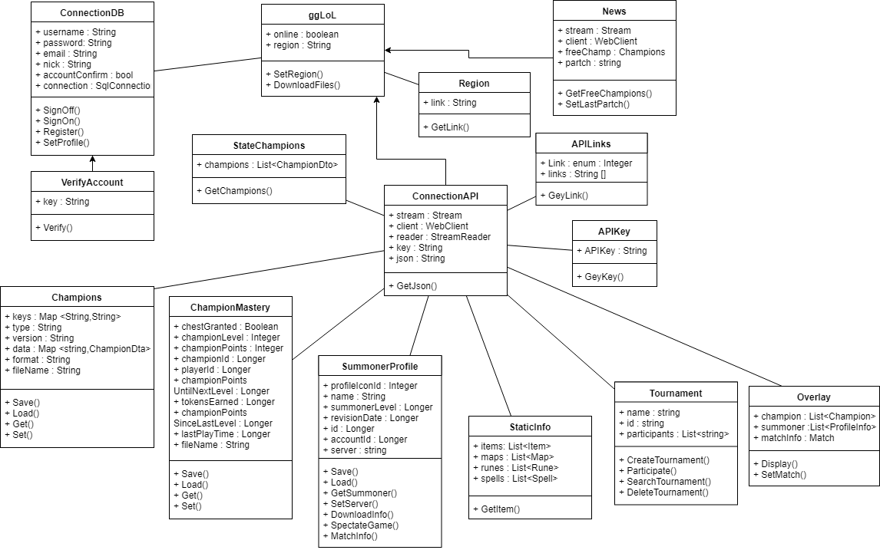

5. Initial planning and expected deliveries

5a. Expected deliveries
- Version 1: Class creation for generic data collection (and API key for connect). Creation of non-functional classes of champions and profile info.

- Version 2: "News" page functionality where information of the latest game update (obtained by web) and rotation of free champions of the week will be displayed.

- Version 3: Functionality of the "Champions" page, where the basic information of the champion (stats, splash art, lore, difficulty) will be displayed in a new window. Implementation of saving the champions information in local (not images) in txt. This data will be obtained from the API.

- Version 4: Functionality of the "Game Information" page, where static information of the game will be displayed (runes, maps, objects, profile icons, spells). Implementation of saving the static data information in local (not images) in txt. This data will be obtained from the API.

- Version 5: Functionality of the page "Summoner Profile", where basic information of the profile of the player will be displayed (level, summoner name, leagues in ranked and information of lasts games and direct link to more information in web). Implementation of saving the profile information in local (not images) in txt. This data will be obtained from the API.
- Version 6: Complete "Summoner Profile" page functionality, where information of the mastery with champions played (the 3 most played) will be displayed, option to see if it is in game (and which champions are being played). Implementation of viewing profile information locally (not in images) in txt. This data will be obtained from the API.

- Version 7: Extra functionality to download your profile in PDF, with leagues, level, most played champions, number of games played ...

- Version 8: Extra functionality to see more aspects of champion in the section "Champions", in addition to adjustments for the possibility of increasing the data displayed for the champions (recommended objects, damage in each level, name of skills and images). Added in Champions (in local save) recommended items (non-images). This data will be obtained from the API.

- Version 9: Class creation to connect to your own database. Functionality of Login or Register. (In web server, with possibility to access offline).

- Version 10: Creation of public chat to find people with whom to play (created in the application). Extra functionality to verify your League of Legends account through the API.

- Version 11: Functionality of the "Overlay" page. Creation of "Overlay" start-up automation when it detects that the game opens and shows the current information of the game. Implementation of saving the news information in local (not images) in txt.

- Version 12: Extra features to page "Summoner Profile", where you can see information of the game (if it is in one) of the player you have searched (with the support of the class "Overlay"). Extra functionality to enter profiles of other players starting with buttons.

- Version 13: Functionality section "Tournaments", where you can create teams by user names of the application, and you can enrol in tournaments to play with other teams (using the own database).

- Version 14: Spectator player functionality (using commands to open LoL Spectator). You can specify the container folder of the game or it can be detected automatically.

- Version 15: Extra functionality in the player option, where you can watch the best players in the league of your region. Added possibility of download all images in offline mode.

- Version 16: Review and adjustments in application design. Option to change main application colours. Option to change main application theme (light, dark). Functionality of sign off and profile (in application).

5b. Real deliveries
- Version 1 (May 14): Class creation for generic data collection (and API key for connect) non-functional. Creation of non-functional classes of champions and profile info (and Structs for basic info).
- Version 2 (May 15): Class creation “News” non-functional. Can’t get Champions free or show last patch to the game in News. Update API Key for connect (return value) and complete more variables (Structs) in Champion.
- Version 3 (May 16): Creation of class to objects statics in game (Spells). Creation of Serialize and Deserialize methods for Save and Load in local info to Champions and Spells.
- Version 4 (May 17): Creation of class Database and creation of class to objects statics in game (Item and Map).
- Version 5 (May 18): Fixed Classes Items and Map. Created Classes Profile Icon, Region and Runes. Implemented Save and Load options and Download File Data.
- Version 6 (May 21): Fixed all Classes (Static Data). Created class Champion Mastery and API Key. Fixed errors to class Connection API. Now, the project can receive and save data. Creation for all Classes (Static Data) Serialize and Deserialize methods for Save and Load in local.
- Version 7 (May 22): Created Methods for create PDF Files with basic information to Summoner Player. Created Screen for Loading while program received data. Fixed a little error in Connection API. Implemented library PDF Sharp (The button is missing on the screen for create PDF).
- Version 8 (May 23): Creation Method for Download Static Data, mode Asynchrony. Settings to design to show download.
- Version 9 (May 24): Created Class User with Methods Save (for Save in a file) and Encrypted (for password). Modify Verify Account.
- Version 10 (May 25): Design Fixed.
- Version 11 (May 26): Changes in File Save for User Info. Created Section for Select Region.
- Version 12 (May 29): Create Option for change Colour. Created Button for change Region (in pages Summoner Profile, Champions and Game Info). To fix Check Box in Profile.
- Version 13 (May 30): Create Class State Game for Status Game.

6. File formats

6a. Plain files format
Static data can be saved and loaded locally by the JSON file type.
The login data can be saved locally by the ggLoL file type, where the username, password (encrypted), custom settings and nick will be saved. Example:
Name
Password (Encrypted)
Email
Nick
Nick-Verification (0 or 1)
Colour - Accent
Theme

6b. Entity-Relationship Diagram (If needed)
(…)

7. Problems found and solutions

8. Improvements or restrictions to the starting design

9. Screenshots of the final project

10. Source code of the final project

